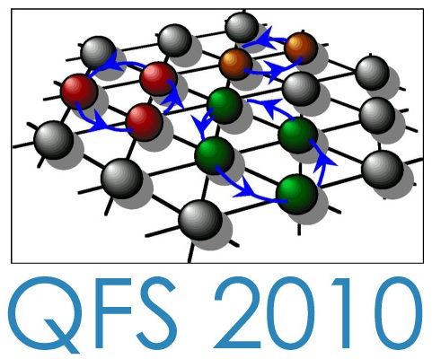

Financial Support Form for Young Researchers
(<<10 years after master degree)

Fill in and send by e-mail to qfs2010.contact@grenoble.cnrs.fr
with “subject” : financialsupport-yourname

Surname:
First Name:
Gender: Male Female
Date of birth: DAY MONTH YEAR
Place of birth: City Country
Nationality/ies (CEE and/or other)
Passport: Country: Passport Number:

Personal address and contact (mail, phone, fax) :

Professional address and contact (mail, phone, fax) :
(Laboratory, University, Company, etc.)

If you are planning to move soon to another laboratory/University, please indicate it here:

Your status (Student, PhD, Post-doc, experienced researcher, Engineer, etc.
Date and nature of you last diploma (Master, PhD, etc…)
Name of thesis advisor, group leader, scientific or technical responsible:
Names and mail addresses of researchers/engineers who can provide letters of support (3 max.) :

Fields of work in research and/or engineering:
Other fields of interest for future work:

Attach the following files :
Copy of passport (scanned document - pdf, jpeg, gif, etc..)
Copy of Diploma (scanned document - pdf, jpeg, gif, etc.)
Your Curriculum Vitae (max 2 pages)
A letter of motivation explaining why the Conference QFS2010 is useful for your career. (max. one page).

